ENG 4 Final Project Report - Desk Lamp

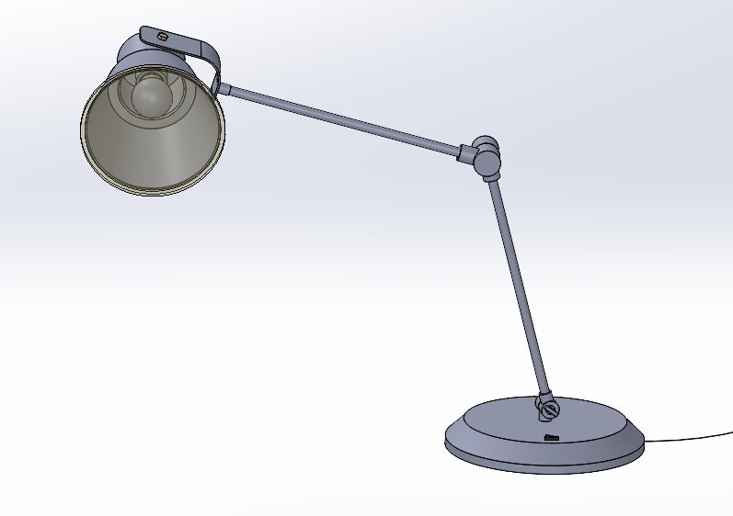

Nick Kim

Erin Min

Aurian Malhotra

Section: A03

TA: Xuefeng Xu

3/12/2025

**Table of Contents**

Assembly Description………………………………………………………2

Challenges…………………………………………………………………..6

Improvements………………………………………………………………14

Project Summary…………………………………………………………...18

Modeling Process…………………………………………………………...21

Working Drawings…………………………………………………………28

**Assembly Description**

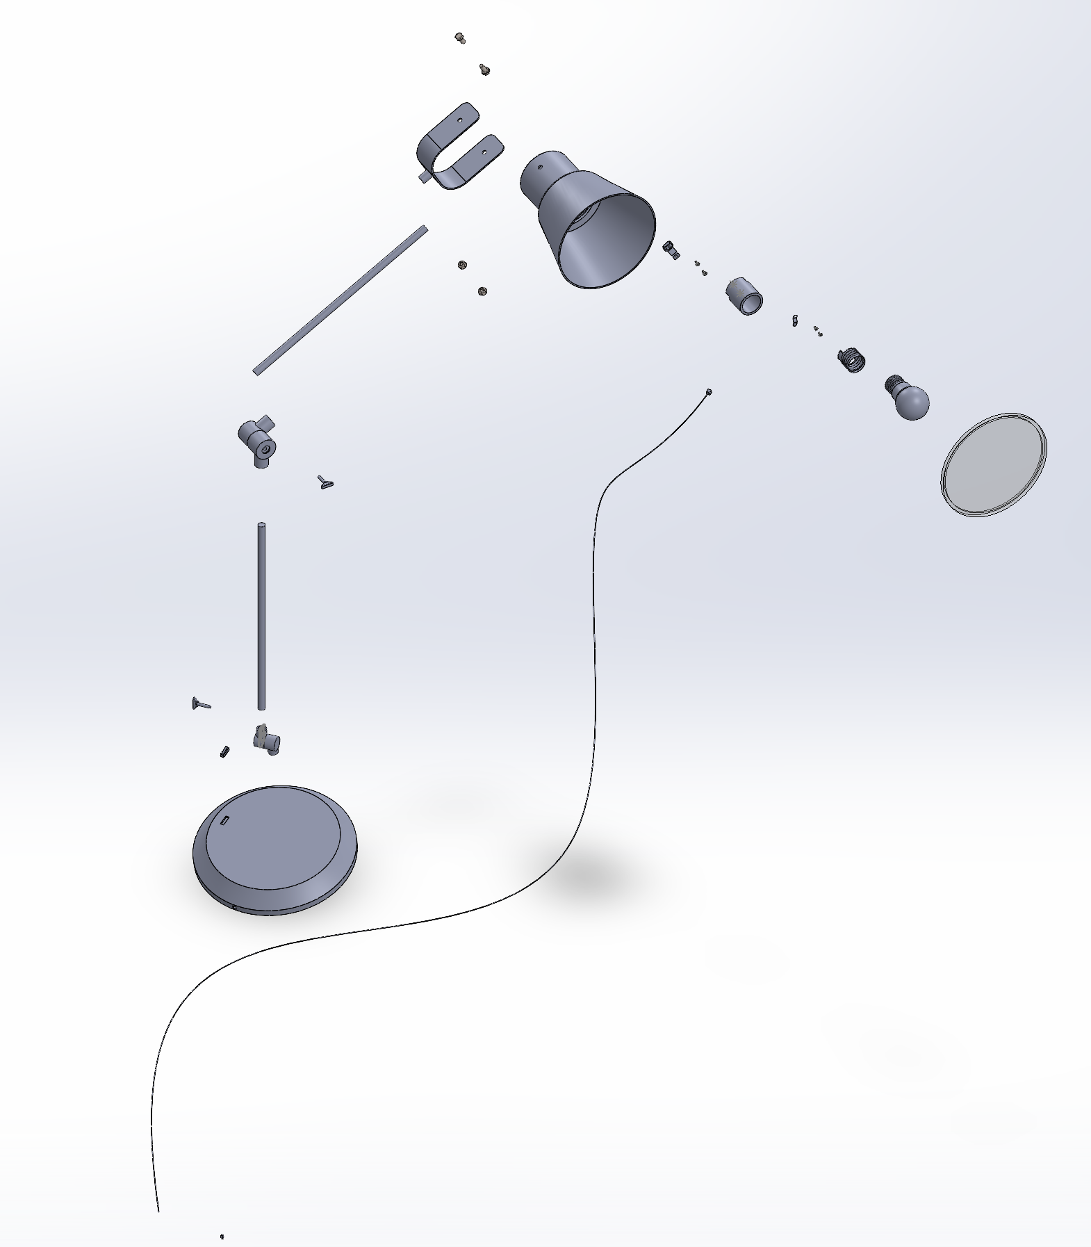

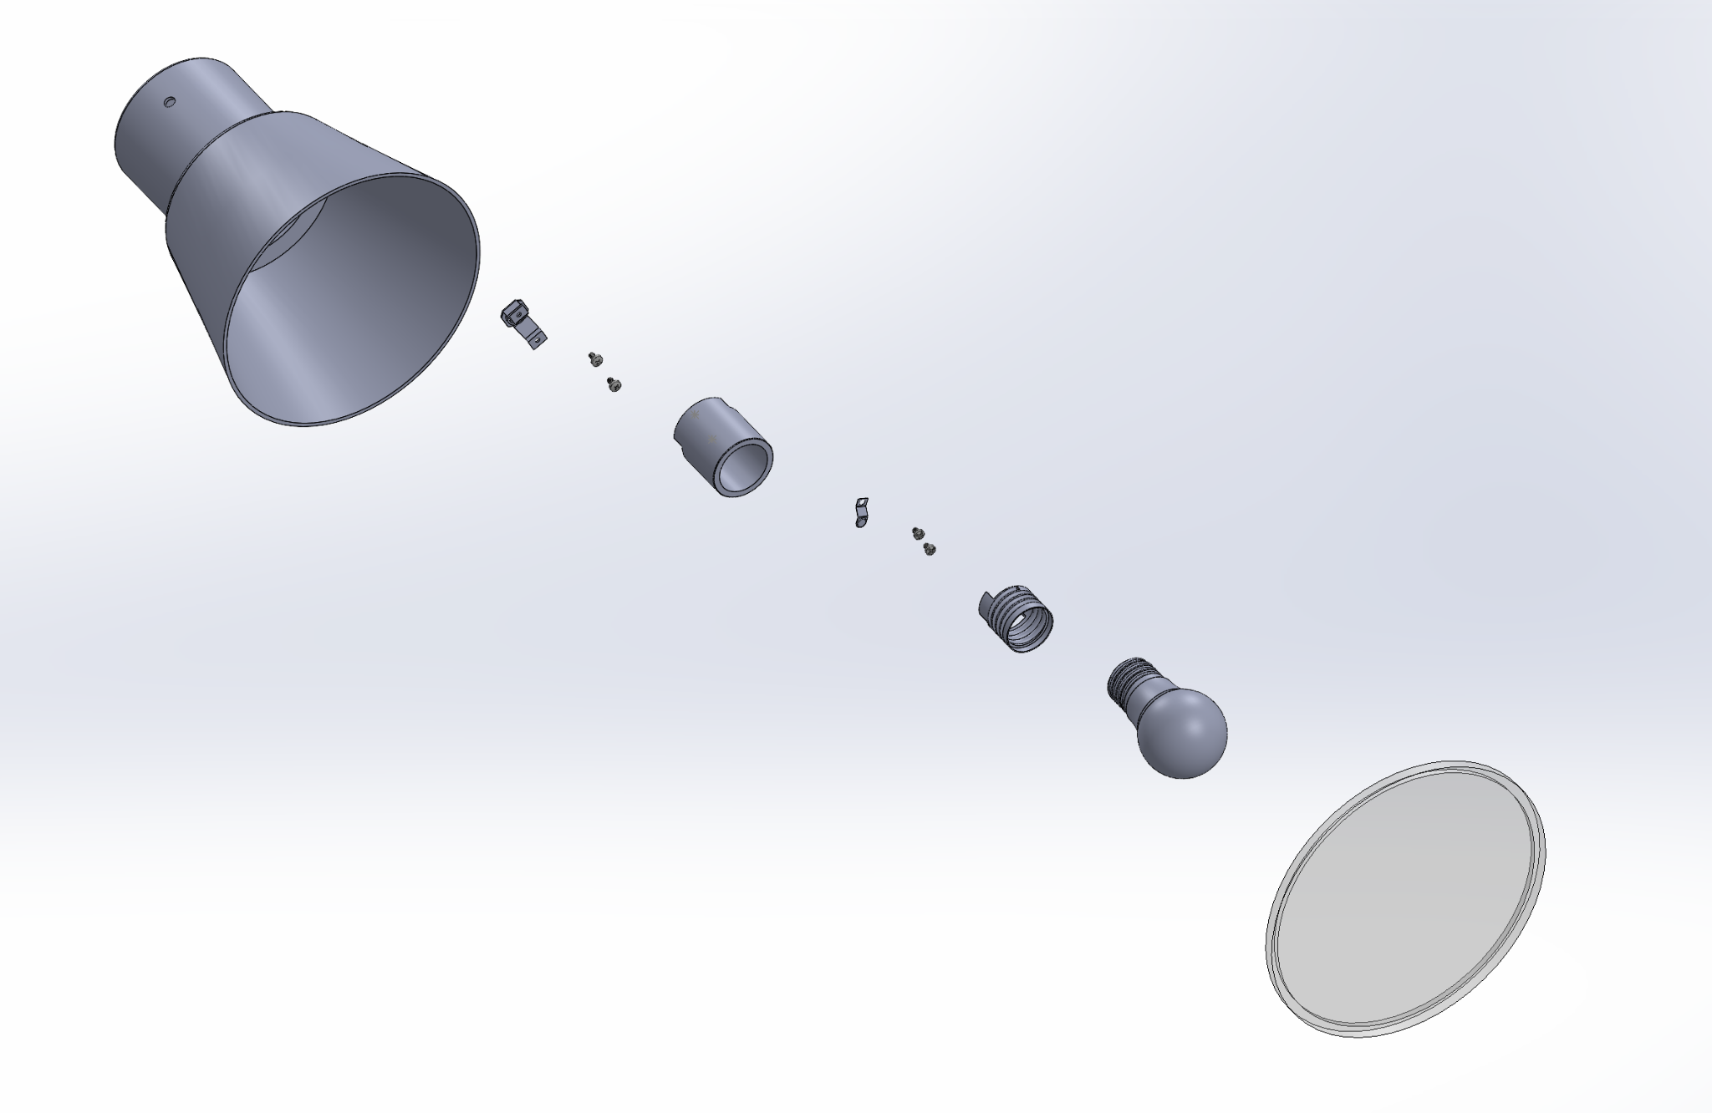

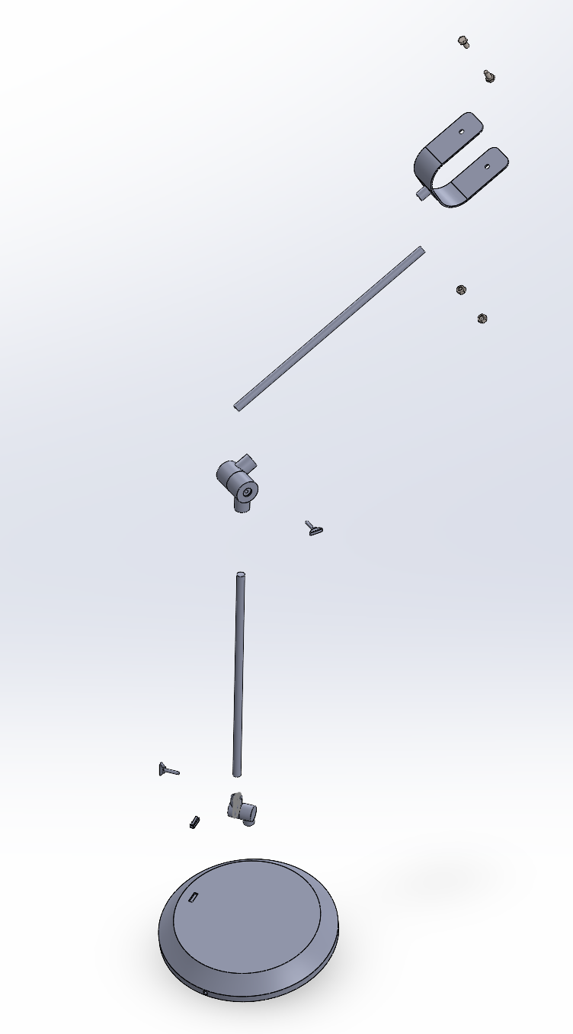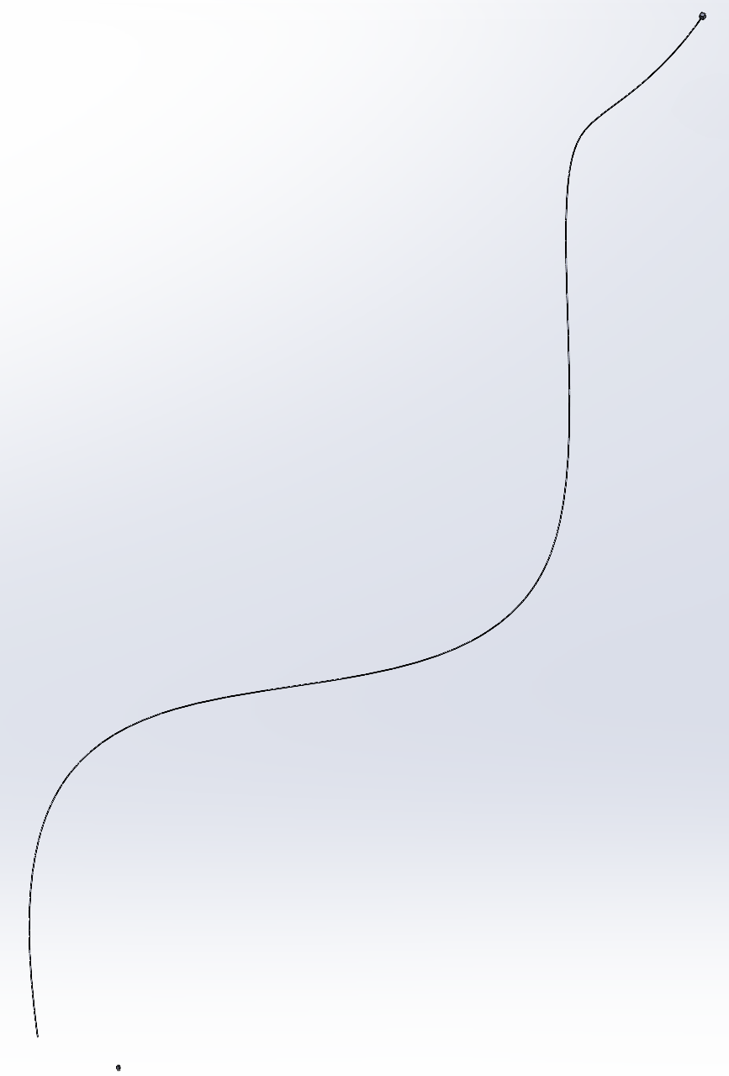

Our assembly model is of an adjustable desk lamp with a hinged, articulating arm that allows movement in multiple directions. The desk lamp consists of 17 main parts. These are the Lamp Head Housing, Lamp Head Pivot Mechanism, Lower Arm Segment, Upper Arm Segment, Lamp Base, Hinge Joint (base to lower arm), Hinge Joint (upper arm to lower arm), Tightening Screw, Light Bulb, Light Diffuser, Power Plug, Power Cord, Switch, and lastly the Light Bulb Socket sub-assembly consisting of the three parts Base, Bracket, and Screw. Erin was in charge of the Lamp Head Housing, Lamp Head Pivot Mechanism, Lower Arm Segment, Hinge Joint (base to lower arm), and Tightening Screw. Nick was in charge of the Upper Arm Segment, Hinge Joint (upper arm to lower arm), and the Light Bulb Socket parts Base, Bracket, Terminal, and Screw. Aurian was in charge of the Light Bulb, Light Diffuser, Power Plug, Power Cord, and Switch. We also imported certain parts including an M6 formed hex screw, M6 hex nut, M3x4 Phillips machine screw, M3x5 Phillips machine screw.

The majority of the mates used in the assembly were coincident and concentric mates, coincident mates to put parts flush against each other, and concentric mates because parts like the Arm Segments and Hinge Joints needed to be concentrically aligned as well as the Light Bulb socket parts. We used distance mates to align certain parts together, for example the Lamp Head housing and the Lamp Head Pivot Mechanism. Parallel mates were used as well to align certain lines/edges of parts as necessary, for example for the alignment of the Bracket and the Light Bulb Holder. We all worked together on the assembly, each of us assembled our own parts.

**Challenges**

*Aurian Malhotra*

**Weighted Base**

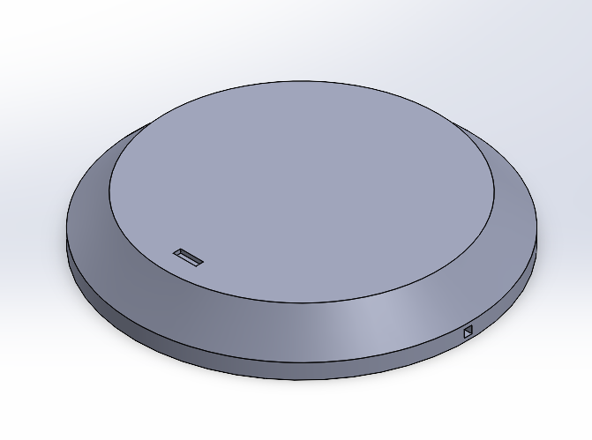

No Challenge

**Light Cover**

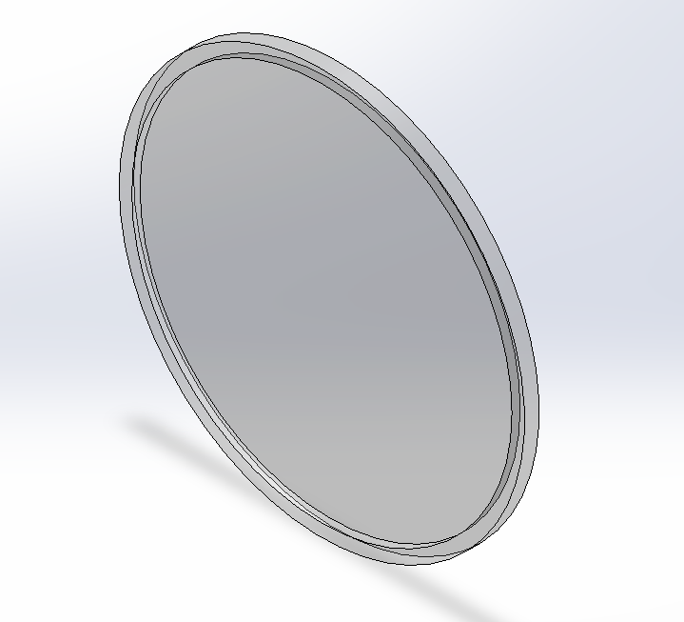

Not much of a challenge, it took some time to figure out how to make the cover transparent to allow for light to pass through via the light bulb.

**Power Cord**

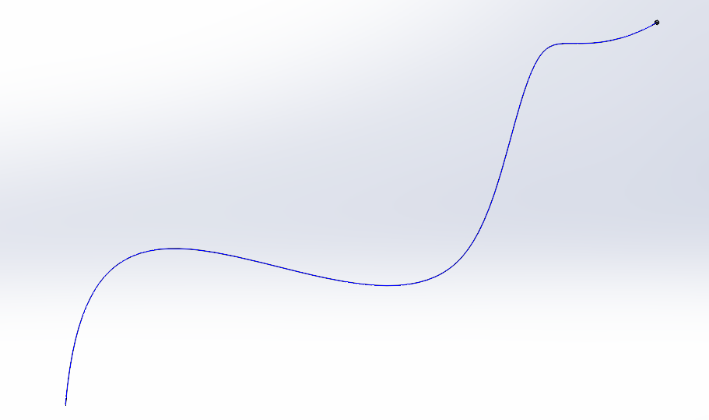

No challenge, I learned how to use projected curve of 2 curves on planes XZ and XY, this allowed me to give a 3D aspect to the design

**Power Plug**

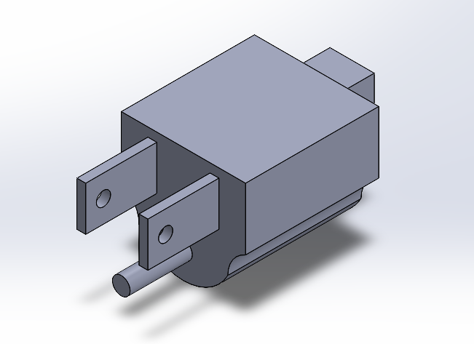

Originally the power cable was one part with the plug and cord. The first design, I made the cord the same as it is currently made, then I added the plug with a series of sketches/extrudes at the end of the cord. Because of this, I was no longer able to adjust the length of the cord. Once I added it to the assembly it was unproportionate with the rest of the parts, so having to adjust it possibly multiple times, I made them two parts so each could be easily adjusted

**Switch**

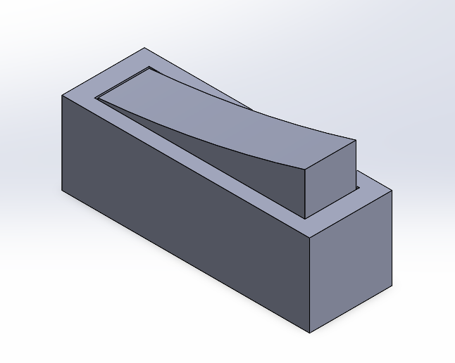

It was challenging to accurately model the geometry of the

switch to get the correct shape and look of the switch itself.

The casing wasn’t challenging.

**Light Bulb**

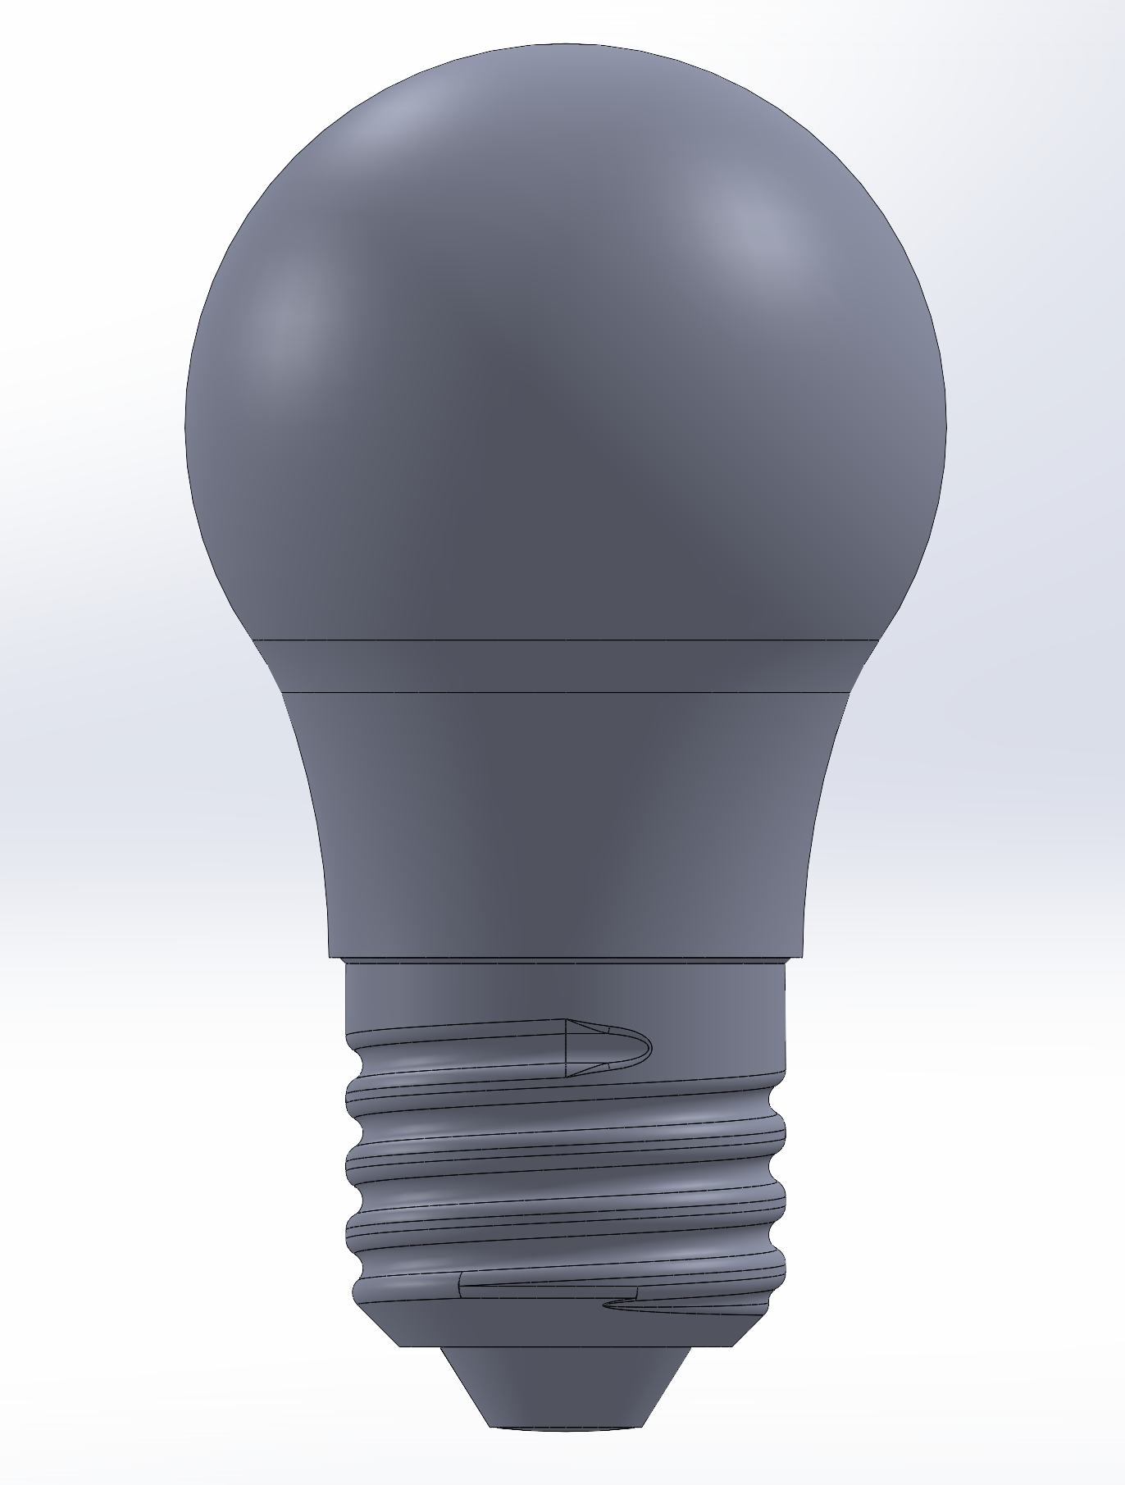

The design I chose to approach the light bulb was a brain workout, but felt very intuitive until we had to add it to the light bulb holder. Because of how I modeled the part, details below, it was not easily adjustable for the holder as many minor adjustments were required, it simply wasn’t possible to make so many adjustments with such a design.

*Erin Min*

**Lamp Head Housing**

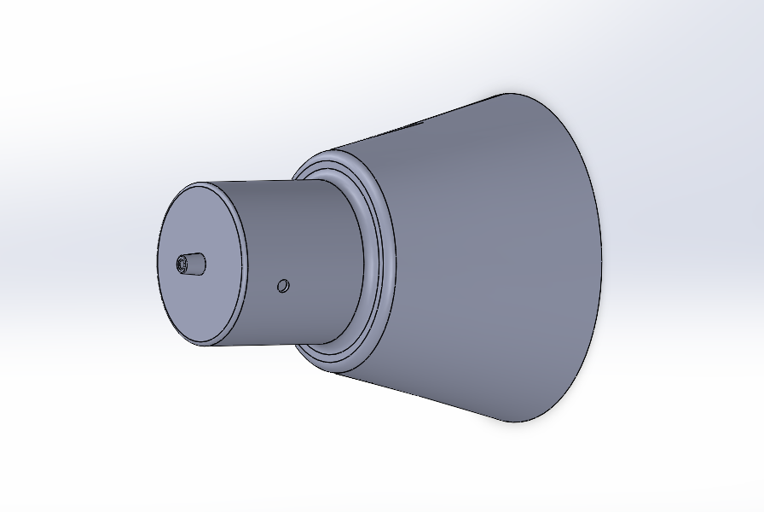

A challenge in creating the lamp head housing was deciding on the shape and dimensions, I looked at different models of desk lamps to decide on these things. Once I decided on the shape and dimensions however the actual modeling was quite simple.

**Lamp Head Pivot Mechanism**

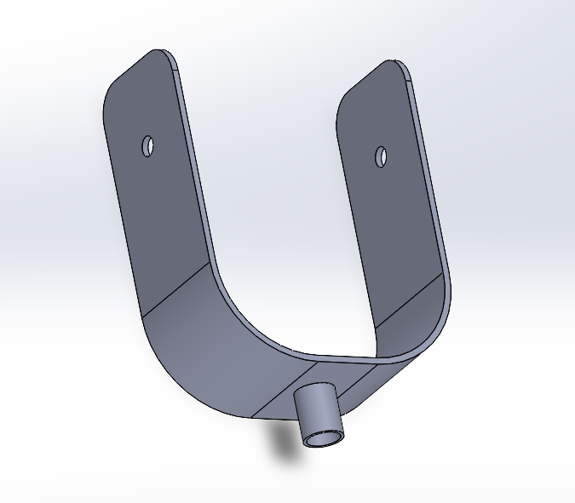

A challenge with the pivot mechanism was creating the thin U-shaped sketch necessary to extrude and create the main structure. I had to use a combination of lines and arcs, and at first I wasn’t sure which tool to use to create the closed sketch but after discovering the “offset entities “tool it was much easier.

**Tightening Screw**

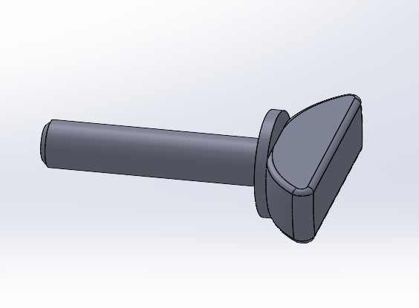

For the tightening screw the only challenge was to make sure it would fit into the hinge joints so it was important to cross check the dimensions of the extruded cuts in the hinge joints.

**Hinge Joint (base to lower arm)**

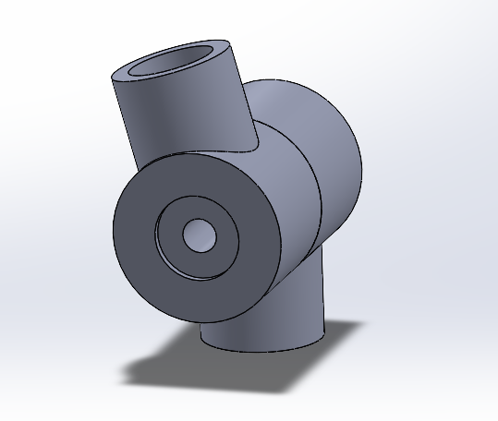

The biggest challenge in creating the hinge joint was putting the top hinge at an angle relative to the overall structure. I had to play with different reference planes but eventually I made a rectangular sketch and used a point and right edge of this sketch that allowed me to create a reference plane that I could extrude the top hinge from.

**Lower Arm Segment**

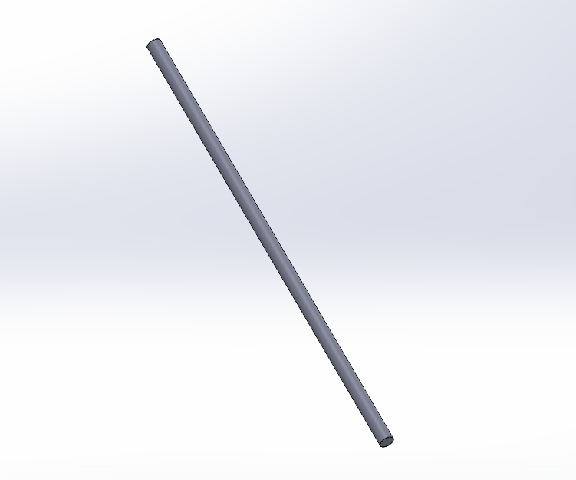

No challenge

*Nicholas Kim*

**Upper Arm Segment**

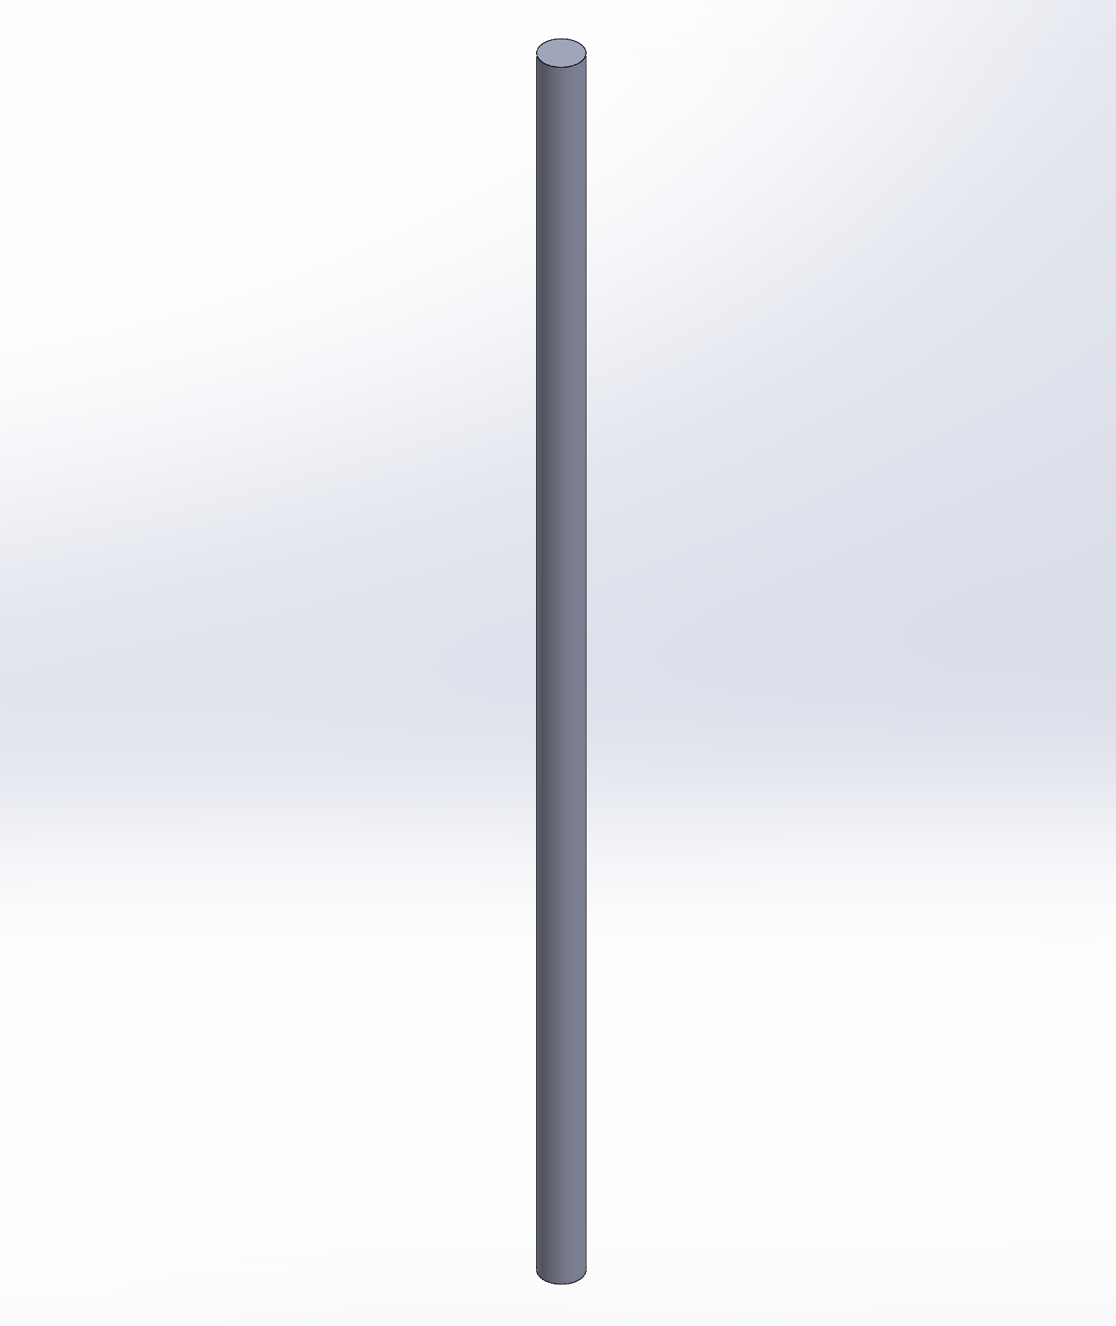

No challenge

**Hinge Joint (Upper Arm to Lower Arm)**

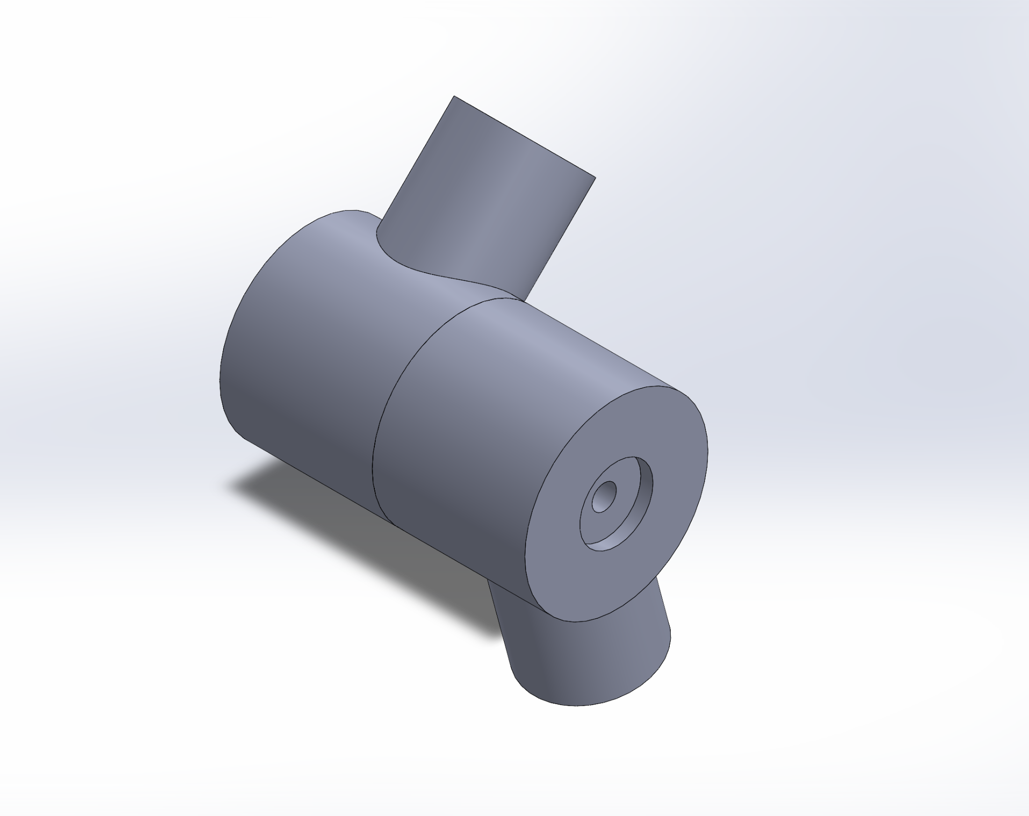

A difficulty when creating the hinge joint for the lower arm to the upper arm was creating the top hinge and the bottom hinge at angles. It was difficult to orient it correctly with the drawing, but I was able to succeed after utilizing different reference planes. I used a rectangular sketch and used a point and edge of the sketch in order to create a reference plane. That plane was then used to make the extrusion at a correct angle.

**Light Bulb Socket (Screw)**

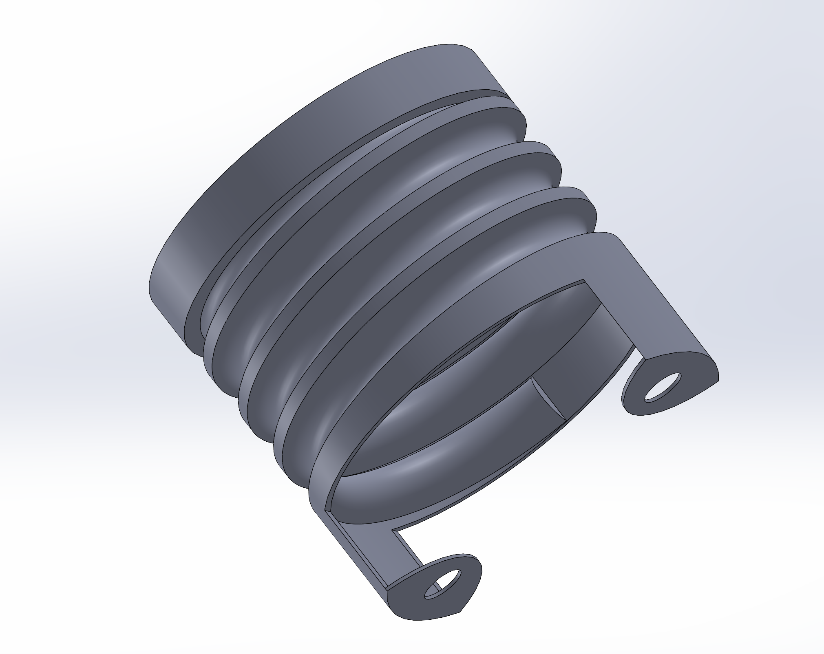

The main challenge when creating the screw was creating the helix to fit the threads of the lightbulb. It was a simple process in terms of steps, however, it was difficult to produce a snug fit for the threads of the lightbulb. I ended up just matching the helix cut out of the lightbulb, but it still did not fit in precisely.

**Light Bulb Socket (Base)**

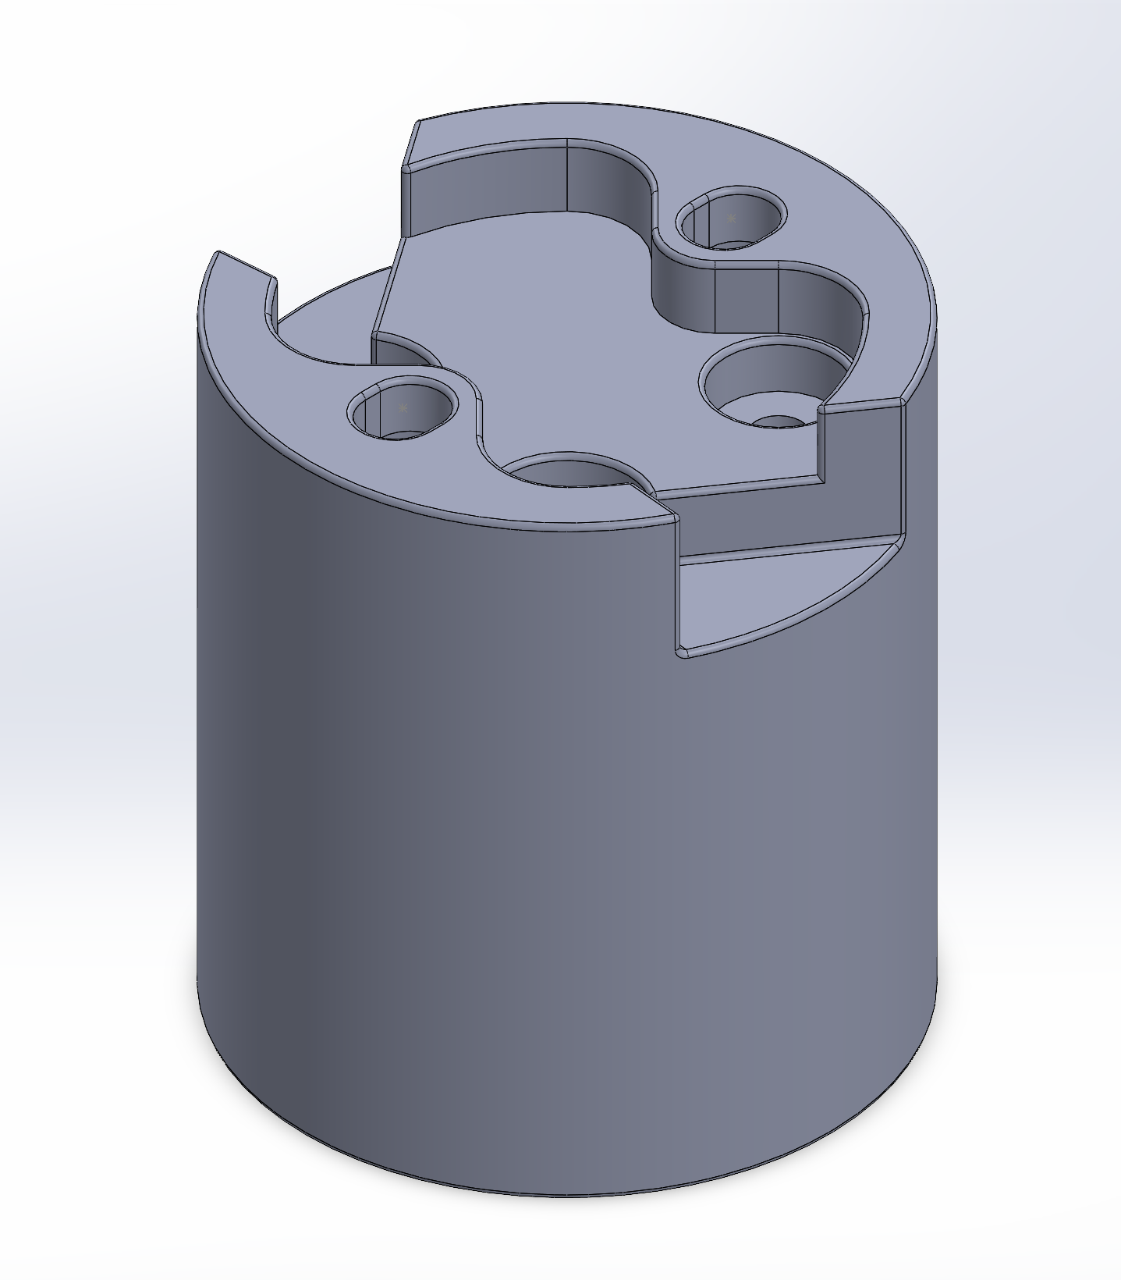

The light Bulb Socket was the hardest to create out of all the parts I made. This is because there were so many divots and hole cuts within the base in order to connect and hold all the components of the socket together. The dimensions of the holes had to align with the dimensions of the screws. In the end I could not get the exact curvatures of the cuts on the base, however I was able to still mimic the cuts to a negligible degree.

**Light Bulb Socket (Bracket)**

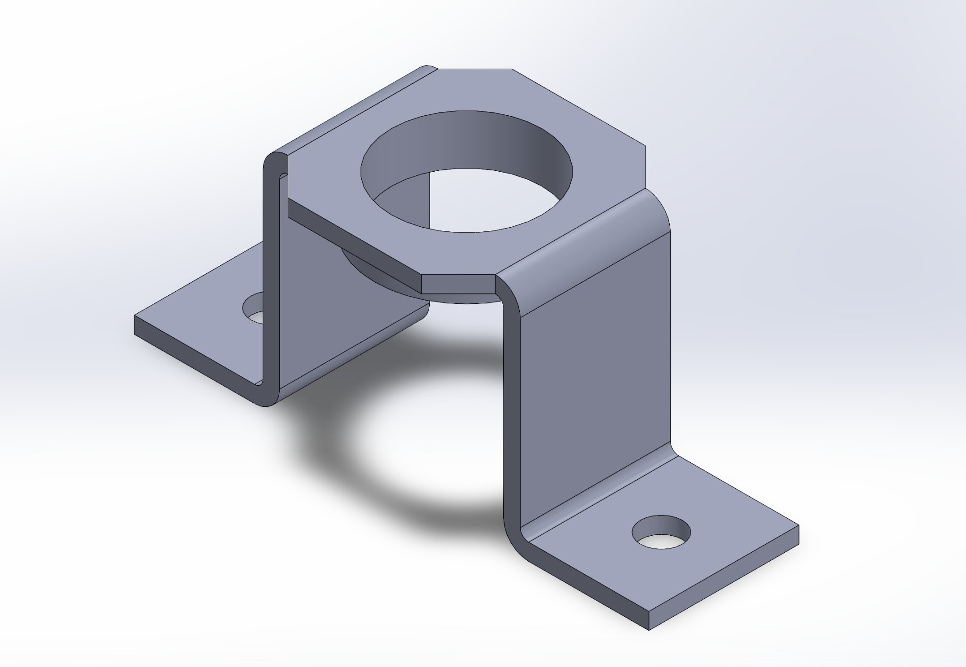

There was not too much of a challenge when creating the bracket that connects the light bulb socket’s base and screw segment. However it took a bit of time to get the correct dimensions and angles of the top, octagonal base.

**Light Bulb Socket (Terminal)**

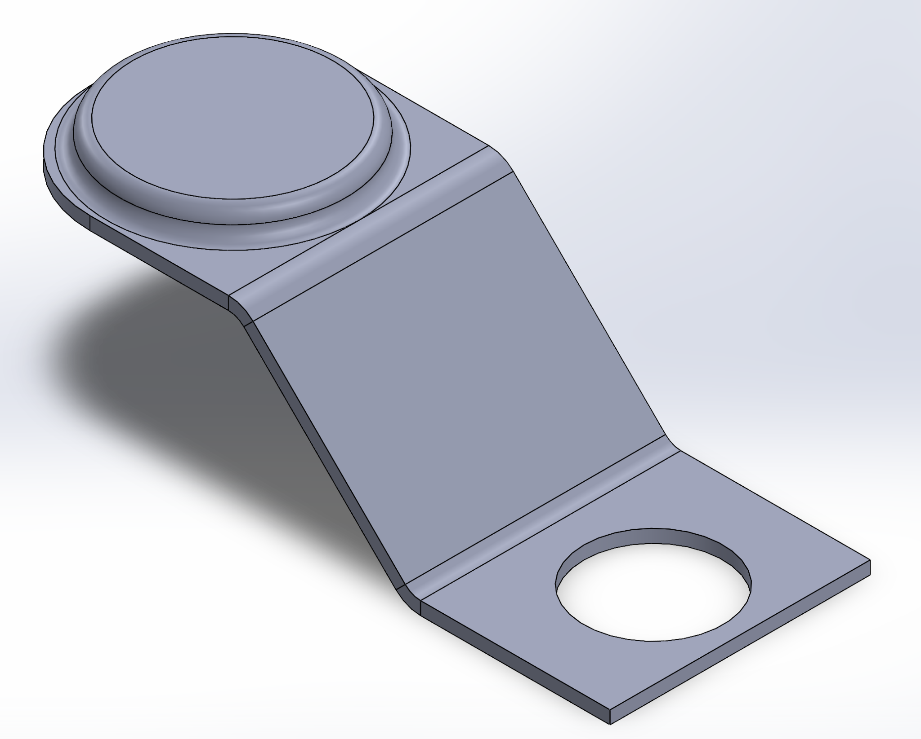

There was not too much of a challenge when creating the terminal. The only somewhat challenging part was getting the angle of the terminal correct.

**Improvements**

*Aurian Malhotra*

**Weighted Base**

A few improvements can be made to the weighted base relating to the overall stability. I could add a denser material to the bottom layer specifically, this would add weight near the ground lowering the center of mass. Increasing the base’s surface area creates larger support which would improve balance and prevent tipping. Finally, instead of the lofted design, which creates thinner and uneven surfaces, I could extrude the base fully making it more solid and uniform in density, adding more mass and stability.

**Light Cover**

Instead of a flat surface, the diffuser could have a concave or convex surface shape which would allow light to emit more evenly compared to a flat surface.

**Power Plug**

I could have spent more time on the plug specifically to give it a design closer to a real power plug rather than the general shape. I also could have added specific material to different pieces to show what is metal and what is plastic covering.

**Power Cord**

Instead of being fancy with the design and creating two different plane splines and projecting it, I could have simply sweeped one spline so the design wouldn’t be as messy and all over the place. It would look cleaner with a simpler spline sweep. Finally, the design should use PVC or rubber material for the cord.

**Switch**

Could have used a simple push button rather than a switch, simpler design, and simpler assembly.

**Light Bulb**

Separating the glass bulb and metal base into revolved features could have allowed the base to be more easily adjustable. The two circular profiles of the glass were hard to adjust after adjusting the base of the metal piece, so two different parts would allow the metal base to be adjusted more easily without having to worry about changing the glass part.

*Erin Min*

**Lamp Head Housing**

An improvement that could be made to this structure is playing with the shape of the lamp head housing as different shapes influence how much light is let through, but I was satisfied with this structure and it’s a very standard lamp head housing.

**Lamp Head Pivot Mechanism**

The pivot mechanism could be improved by making a hinge joint at the attachment point between the pivot mechanism structure and the upper arm segment so that the lamp has another mode of motion.

**Tightening Screw**

The tightening screw could be improved by modeling the actual threads.

**Hinge Joint (base to lower arm)**

An improvement for the hinge joint could be modeling the two split bodies (hinges) as two separate parts, because I used the “split function” but that doesn’t allow for the parts to rotate relative to each other. If they were then mated concentrically it would allow for the lower arm segment to rotate in a way that is more similar to how we would want the desk lamp to behave in real life with regards to adjustable motion.

**Lower Arm Segment**

No improvements

*Nicholas Kim*

**Upper Arm Segment**

No improvements.

**Hinge Joint (Upper Arm to Lower Arm)**

One major improvement that could be made to the hinge joint is splitting the two bodies of the hinges as two separate parts. This would allow the hinge to rotate as two separate parts, allowing the arms to have more freedom in rotation. It would let the lower arm segment to move and rotate separately from the upper arm.

**Light Bulb Socket (Screw)**

One improvement to the light bulb socket’s screw section would be to have a more snug fit with the threads of the lightbulb. I tried to represent the same threads made for an E27 light bulb (the type of lightbulb we modeled) but was not able to get the exact precision. It was only slightly off, but it would be a big improvement to the design.

**Light Bulb Socket (Base)**

An improvement to the light bulb socket’s base would be to include a helix for each of the holes made at the top. This would let the screws fit in more accurately, as it would let the threads of the screw fit into the base, allowing for the screws to have a snug fit and accurately fasten the parts together.

**Light Bulb Socket (Bracket)**

An improvement to the light bulb socket’s bracket is the same as its base. Including a helix for each of the holes made at the top would let the screws fit in more accurately, as it would let the threads of the screw fit into the bracket. This allows for the screws to have a snug fit and accurately fasten the parts together.

**Light Bulb Socket (Terminal)**

An improvement to the terminal of the light bulb socket is to include a helix for its hole, allowing the screws to fit in more accurately.

**Project Summary**

*Aurian Malhotra*

**Weighted Base**

The lamp base serves as the foundation of the lamp, without it the arms would topple over. The base adds general stability and weight to the overall assembly.

**Light Cover**

The light diffuser is used to soften the light emitted to be easier on the eyes of the user. It also allows for light to be spread out more evenly throughout whatever profile it is shining on.

**Power Cord**

Allows electrical power to flow from a source, the wall outlet, to a device, our lamp. Without the power cord, our design simply won’t work, as we require power.

**Power Plug**

The power plug connects the power cord to a source, the wall outlet. Our power plug is essential for the design since it is a part of the power cord. As said earlier, the lamp requires power to operate.

**Switch**

The switch controls the flow of electricity to power the lamp either on or off.

**Light Bulb**

The function of the light bulb is simply to produce light, illuminating the workspace for tasks. The light bulb is the most essential part of the lamp, of course, because without it, the lamp wouldn’t be able to generate light. Without this, our lamp would have lost all its purpose.

*Erin Min*

**Lamp Head Housing**

The purpose of the lamp head housing was to house and protect the lightbulb.

**Lamp Head Pivot Mechanism**

The lamp head pivot mechanism was attached to the lamp head housing and allowed the lamp head to have a range of motion to be adjusted upwards and downwards which is useful for a desk lamp if you want the light to be directed more upwards/downwards.

**Tightening Screw**

The tightening screw served the purpose of tightening the hinge joints to lock the arm segments in place after making any adjustments to the angles of the arm segments.

**Hinge Joint (base to lower arm)**

The hinge joint served the purpose of joining the base to the lower arm segment while allowing the lower arm segment to be adjusted to be at an angle of choice.

**Lower Arm Segment**

The lower arm segment was the lower arm of the desk lamp, simply giving the lamp more height.

*Nicholas Kim*

**Upper Arm Segment**

The purpose of the upper arm segment is to give more height to the lamp. It also acts as a way to connect the lower arm segment and the head of the lamp, and lets there be another segment for the lamp to move.

**Hinge Joint (Upper Arm to Lower Arm)**

The purpose of the hinge joint for the upper arm and lower arm was to connect the upper and lower arm together. It also allows these arms to rotate up and down, allowing more freedom on where to shine the light.

**Light Bulb Socket (Screw)**

The purpose of the screw of the light bulb socket is to join the socket and the lightbulb. It allows the lightbulb to be screwed into the socket.

**Light Bulb Socket (Base)**

The purpose of the base of the light bulb socket is to house all the components of the socket together. It holds the screws, the bracket, and the area where the light bulb will be screwed in.

**Light Bulb Socket (Bracket)**

The purpose of the bracket of the light bulb socket is to join the base of the socket to the component that lets the light bulb to be screwed on.

**Light Bulb Socket (Terminal)**

The purpose of the terminal of the light bulb socket is to let electricity flow into the light bulb.

**Modeling Process**

*Aurian Malhotra*

**Weighted Base**

Starting with a 220mm diameter circle extruded, then loft the top face to a smaller 180mm circle. Followed by 2 extruded cuts allowing for the switch and connection of the power cord.

**Light Cover**

Start with a circle slightly larger than the lamp head housing, extrude. Offset the circumference of the face and extrude this rim to latch onto the head housing. Edit appearances of light diffuser and change color to tan and transparency to 75%.

**Power Cord**

Sketch a small square and extrude, this cube will connect to the foundation. Sketch a spline starting at the cube on the XY plane, and a spline on the XZ plane. Projected curve of the XY and XZ splines to get a 3D spline. Sketch a circle with a diameter of the cord onto the cube and sweep the projected curve.

**Power Plug**

Sketch an outline of the power plug face and extrude. Sketch the 2 rectangular prongs and one cylindrical prong and extrude. Sketch a circle on the now extruded rectangle prong and extruded cut to get the circle cuts in the rectangular prongs. On the back face of the power plug, extrude a cube and extrude cut a circle to allow connection to the power cord.

**Switch**

Sketch a rectangle on the top plane and extrude. Sketch a smaller rectangle on the top face of the extruded rectangle. Create a small offset and extrude cut, next extrude the inner rectangle then cut at an angle to give the shape of the switch.

**Light Bulb**

Imagine the cross section of the bulb, sketch lines outlining on half of the cross section. Add a line down the middle showing the symmetry, and revolve around this line to give the general shape of the bulb and metal base. Add a reference plane at the circle between glass and metal base and sketch a helix shape around the metal base. Sketch a circle on the face of the metal base as a reference for the spiral, and sweep the helix profile to show the coil around the metal.

*Erin Min*

**Lamp Head Housing**

First two circular sketches, one with a larger diameter than the other, on planes separated by a distance were lofted. Then the surface with the larger diameter was shelled. A cylinder was extruded from the end opposite to the shelled side. There was an extruded cut performed on the cylinder to create the housing for the lightbulb. An extruded cut was done on two small circles on the sides of the lamp head housing for the screws to go in. Lastly to make the part for the power cord to go through, a trapezoidal sketch with the outer edge at an angle of 5 degrees was revolved about the axis perpendicular to the lamp head housing surface. Several edges were filleted to make them smooth.

**Lamp Head Pivot Mechanism**

A thin U-shaped sketch was made using the line tool and the arc tool, then using offset entities and offsetting everything by a prescribed distance. This sketch was then extruded. Extruded cuts of a circle towards the top of each arm were made (2 total) for the attachment points of the lamp head housing. A cylinder was extruded from the flat surface of the U-shape at the bottom of the U, and an extruded cut was made in this cylinder for attachment of the upper arm segment. The corners at the top surfaces of the U were filleted to make them smooth.

**Tightening Screw**

A sketch of what resembles a half of a goblet, with a long rectangular portion with a chamfered edge (the long part of the screw), a short and wider rectangular portion (the base for the tightening mechanism), and a curved portion using an arc that looks like the cup part of a goblet (the tightening mechanism) was revolved. Then an extruded cut on the circular surface was made all the way down to the base so that a center slice to form the tightening mechanism remained. Edges of the tightening mechanism were filleted.

**Hinge Joint (base to lower arm)**

First a cylinder was extruded to form the main structure of the hinge joint. An extruded cut was made to form a shallow circular cut on one side. Another extruded cut was made of a small hole that extended halfway through the structure (this is where the tightening screw goes in). The “split” function was used to separate the cylinder into 2 equal parts using a reference plane. For one of the split parts, a reference plane to cut through the center and a sketch of a rectangle tilted at an angle with two corners lying on the circular surface was made on this plane. Another reference plane was made using the upper right corner of the rectangle and the right edge of the rectangle. A cylinder was extruded “up to next” downwards into the main cylindrical structure with the same diameter as the width of the rectangle formed earlier. Another cylinder was extruded up to the main structure aligned with the center of the other split body, in a similar fashion but this time not at an angle. The top surfaces of each smaller cylinder were shelled.

**Lower Arm Segment**

A sketch of a circle was extruded to form a long cylinder.

*Nicholas Kim*

**Upper Arm Segment**

A sketch of a circle was extruded to form a long cylinder.

**Hinge Joint (Upper Arm to Lower Arm)**

First a cylinder was extruded from on the right plane, creating the main structure of the hinge joint. Next, an extrude cut was made to form a shallow circular cut on one side. Then, another extruded cut was made concentric to the previous cut. This cut was smaller and was extruded almost, but not to the end of the structure. Then, the “Split” function was used to separate the base into two equal parts by using a reference plane. On the left half of the split parts (in the view of an isometric view), a reference plane was made to cut through the center and a sketch of a rectangle tilted at an angle with two corners lying on the circular surface was made on this plane. Another reference plane was made by using the upper left corner of the rectangle sketch and the left edge of the rectangle sketch. This created a top plane for the component, and a circle was extruded to the surface of the base. This same cylinder was made on the other half of the split part, but with a different angle. Lastly, the base was shelled on the inside, and the top surfaces of each smaller cylinder were shelled (allowing the arms to fit into the cylinders).

**Light Bulb Socket (Screw)**

First a circle was extruded upwards from the top plane. Then, a helix was created, starting at the top of the cylinder, extending about ⅔ of the cylindrical base. Then a cut sweep was performed on the helix with the face being a small circle. This created the area where the lightbulb’s threads could fit in. Then, I boss extruded another circle on top of the base, creating extra room for the helix and the top of the base. Next, I shelled the top of the cylindrical base. Then, I created a circular, concentric extrude cut at the bottom base, making sure to leave a thin outer rim. Then I created a rectangular sketch at the center, bottom of the base. This sketch was made so that it leaves two edges on the circle, giving the component small arms. I then used a cut extrude, and extended it both ways. Next, I boss extruded a small flap on one of the arms using a sketch made with the arc tool. Then I created a hole cut on the flap with a cut extrusion so that the component could be screwed in. I then mirrored the hole cut and the extruded flap onto the other side.

**Light Bulb Socket (Base)**

First, I created a circle that was extruded upwards from the top plane. Then my next step was to create cuts at the top to make layers. In order to do so, I first made the curved top layer by cut extruding a sketch made of two circles and connecting each circle tangentially to each other with lines. This sketch was made so it is 45 degrees away from the right plane. This diagonal cut was then mirrored using the right plane (component has right and front plane at its center). Next I used the filet tool to create the wavy effect of the first layer at the top. Next I created the next layer by extrude cutting a sketch made from a circle and lines. It formed a cut that was a triangle cut. I then mirrored this over the right plane. Next, I created circle cuts where the screws would reside by using cut extrude. I created a circle sketch on the lowest layer, and mirrored it over the right plane. I then made one hole on the middle layer that had a shallow, circular cut, and then created a smaller hole that was concentric to the shallow cut. Lastly, I created a hole cut at the top layer. It was made by creating a sketch of two equal circles that were connected with parallel lines at the edge of the circles. I then used cut extrude and mirrored it using the front plane. Next, I shelled the bottom of the component. I then created a boss extrude at the bottom of the shelled out area in order to create a place where a small bracket of the component could reside. This was oriented with one of the holes on the bottom layer of the top of the component. I then filleted this extruded part, and filleted the edges at the top of the base.

**Light Bulb Socket (Bracket)**

First, I created a side profile sketch of the arm of the bracket. I then extruded this outward. Then I cut extrude circular holes on the center of the flat surface of the arm. Then, I created a reference plane from the top plane so that it lined up with the top edge of the bracket’s arm. Using this plane, I boss extruded the top base of the bracket by creating half of an octagon. I then mirrored all of these parts using the right plane. Next, I boss extruded a cylinder at the center of the bottom of the top base. Lastly, I cut extrude a circle “through all” at the bottom of the cylinder of the top base. The circle made for the cut was concentric with the cylinder.

**Light Bulb Socket (Terminal)**

First, I created a sketch of the side profile of the terminal on the front plane. I then used the “sweep” command to create the 3D shape of it. The face used for the sweep command was a rectangular face on the bottom right of the side profile sketch. Next, I created a circular, thin boss extrude at the top base of the terminal. I then performed a cut extrusion at the bottom of the top base. This cut was circular and was concentric with the circular boss extrusion made in the previous step. It basically shelled out the boss extrusion. Next, I used the “filet” tool to round out the top base’s left edges, allowing the left portion of the top base to become a semicircle. I also used the “filet” tool on the edges of the circular cut and circular extrusion made. Lastly, I created a circular cut extrusion at the center of the lower base of the component.

***Working Drawings***



